Overall Equipment Effectiveness

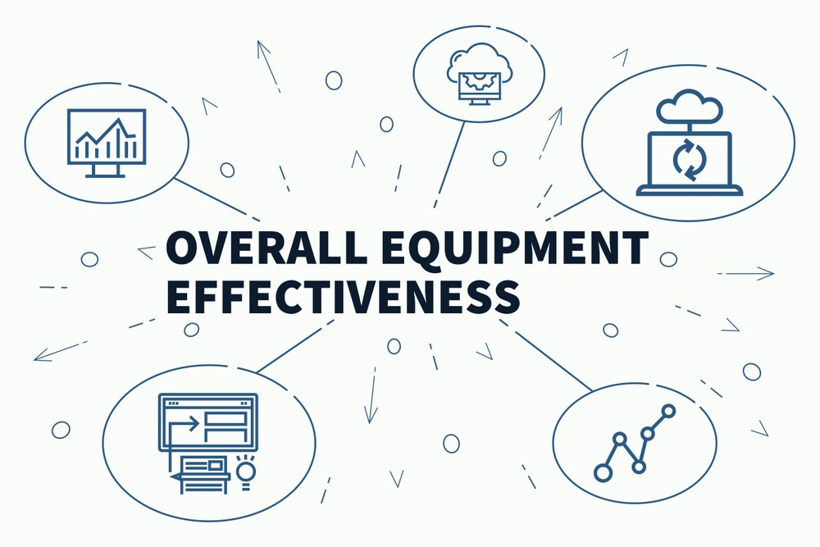

Highlights:

* What is Overall Equipment Effectiveness ?
* Understanding OEE factors
* Calculating OEE
* Effective OEE implementation
* Six Big losses
* Improving OEE

What is Overall Equipment Effectiveness (OEE)?

Overall Equipment Effectiveness , called OEE is a convenient, practical and powerful KPI (Key performance indicator ) which measures manufacturing productivity and then improves the performance of your production processes . In simpler words , it is the process of analysing and measuring how effectively and efficiently a manufacturing operation is utilized as compared to its full efficiency. An OEE of cent percent means that only good parts are produced at the maximum speed and without any interruption. OEE is an effective process to gain insights on underlying losses , bench -marking progress and improving the manufacturing equipment’s productivity.

**Total effective equipment performance** **(TEEP)** is a closely related measure which quantifies OEE against calendar hours instead of only against scheduled operating hours.

OEE analysis with the help of underlying factors

The analysis of OEE starts with the time that the plant is available for production , known as the Available Time for production , from which we subtract the time for Planned stops , which entails all the time periods when the plant is not running . The time that is left is called the Planned Production Time . OEE begins with this time and then all the losses of efficiency are subtracted from the Planned Production time and then those are made the targets to be worked upon for improvement.

There are three major categories of losses : Downtime , performance and quality losses:

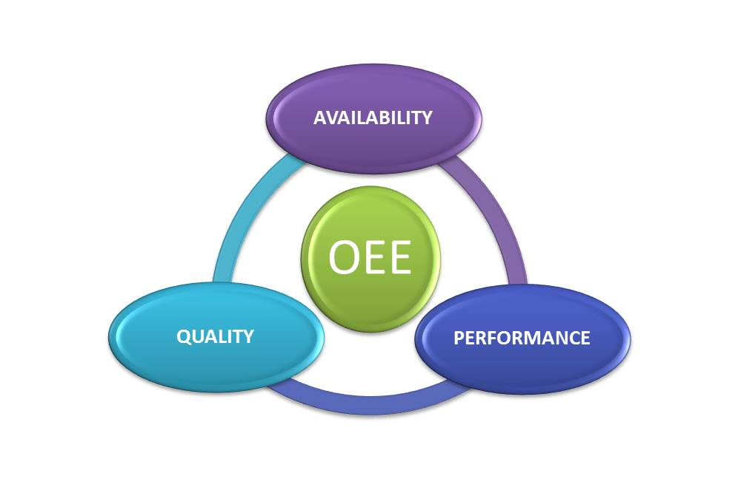

* Availability:

Availability deals with all types of losses that result due to wasted availability or downtime losses . These losses can be a result of a malfunctioning equipment , lack of material or change overs of either shift or product.

The remaining time after Availability loss is eliminated is called Run Time.

* Performance :

Performance deals with Performance losses , that is to say , the losses related to reduced production speed. It takes into account anything that causes the process to take run time less than the maximum possible time. Performance losses can be caused by wearing of machine , operator inefficiency, substandard materials ,etc.

The time remaining after subtracting the Performance Loss is called Net Run Time.

* QUALITY :

The quality factor takes into account the losses resulting due to compromised quality which can be a result of manufactured parts not meeting quality standards , are reworked or downgraded.

The time left at this stage after the Quality Loss is also subtracted is called Fully Productive Time.

So as we can clearly see the above three factors can really help manufacturers to analyse the underlying causes of loss in productivity.

CALCULATION OF OEE

* Direct Method:

A direct and simple approach to calculate OEE is to calculate the ratio of Fully Productive Tome to Planned Production Time , that is,

**OEE=(Good Count * Ideal Cycle Time ) / PPT**

Where PPT = Planned Production Time

* Preferred Method :

Although , there is nothing wrong with the aforementioned method , it is not preferred as it does not provide any insights on the underlying factors governing productivity loss. Hence the preferred method of calculation is:

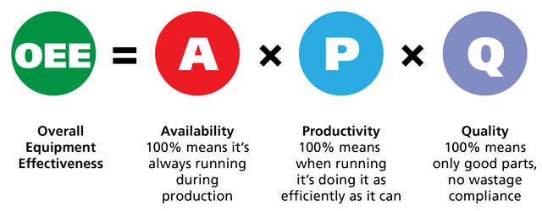

So ,

**OEE =Availability (A) * Productivity (P) * Quality (Q)**

Where,

* Availability (A)= Actual Production Time / Planned Production Time
* Planned Production Time = Total Available Time – Planned Breaks
* Actual Production Time = Planned Production Time -Stops
* Performance(P) = Actual Production Rate / Ideal Production Rate

* Actual Production Rate= Total Count /Total Run Time
* Quality (Q) = Good Parts/ Total parts produced

OEE IMPLEMENTATION



Now having grasped the basics of OEE and how it is calculated let us have a look at the steps that we can follow to successfully implement OEE.

* **STEP 1) Selecting a (Pilot) Machine** : Chose a machine that is easy to overview and where the focus of the improvement strategy must be directed.
* **STEP 2) Draw up OEE definitions**
* **STEP 3) Define and organize OEE data collection:** The data should be easily comprehensible, clearly organized and simple to use.
* **Step 4) Essential Training:** Some time should be reserved for the production team to undergo essential training.
* **Step 5) OEE Data collection :** Do not assume that there is no need for the involvement of operator in data collection. Make sure that there is some initial guidance given to the team during the first shifts.
* **Step 6) Processing the collected data :** The data collected should be processed fast and before the next shift starts. The processing must generate optimized information with a minimum registration burden.
* **Step 7) Giving operator feedback:** The shop floor team should be given a feedback so that they can gain insights about the existing losses and work on eliminating them.
* **Step 8) Informing the management :** Management provides the requirements for improvements and thus should be well informed about the facts and figures and all the right information.

SIX BIG LOSSES

The most common causes of equipment based productivity loss in manufacturing is known as **“Six Big Losses**”. Let us first have a quick overview of these losses.

|  |  |  |
| --- | --- | --- |
| OVERALL EQUIPMENT EFFECTIVENSS | RECOMMENDED SIX BIG LOSSES | TRADITIONAL SIX BIG LOSSES |
| * AVAILABILITY LOSS | Unplanned stops | Equipment failure |
| Planned stops | Setup and Adjustments |
| * PERFORMANCE LOSS | Small Stops | Idling and Minor Stops |
| Slow Cycles | Reduced Speed |
| * QUALITY LOSS | Production rejects | Process defects |
| Startup Rejects | Reduced Yeild |
| * OEE | Fully Productive Time | Valuable Operating Time |

* **EQUIPMENT FAILURE**

Equipment failure takes int account any duration of time in which the equipment is scheduled for production but is not running due to some issues like tooling failure , breakdowns and/or unplanned maintenance . It can also be understood as any unplanned stop or downtime. Equipment failure comes under the category of Availability Loss.

* **SETUP AND ANDJUSTMENTS**

Setup and adjustments takes into account those period of times when the equipment is scheduled but is not running due to setup changeovers , major adjustments ,tooling adjustments ,etc.

* **REDUCED SPEED**

Reduced speed accounts for the time when the running time of the equipment is less than the Ideal Cycle Time. Example of common reasons for reduced speed include worn out equipment, poor lubrication , operator inexperience , etc.

* **PROCESS DEFECTS**

Process defects take into consideration the defective parts produced. Process defects are classified as a Quality Loss.

Process defects can be a result of operator inexperience , incorrect equipment setup , Iot expiration ,etc.

* **REDUCED YIELD**

Reduced yield takes into the consideration the defective

parts produced from startup until stable production is reached. Examples that result in reduced yield include suboptimal changeovers, incorrect setups ,etc.

WAYS TO IMPROVE OEE



* **By assigning a digital champion** which helps organizations to create ownership and accountability for its success and also ensures sustained and successful implementation of OEE.
* **Automating the collection and reporting of the production data** so that there is no hassle about manually collecting data.
* **Visualization of real time OEE** which assists in processing data faster and conveniently.
* **Implementing daily cross functional discussion** sessions is yet another practice that is extremely essential to avoid any communication gaps that will ensure high production quality and improvement.
* **Eliminating the six big losses** by understanding the causes and the amount of losses so that focus can be placed on improvements.
* **Root Cause Analysis (RCA)** : Once we have insights about our company’s six big losses , our next priority should be problem-solving by utilizing RCA which is a process to help us understand the root cause of a problem.

Conclusion

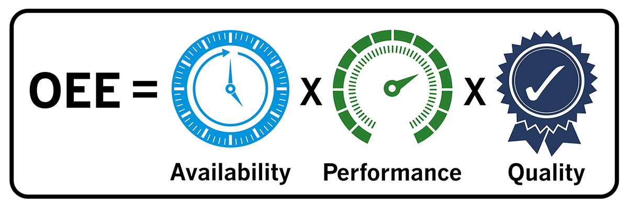

OEE is one of the most crucial process measurements in today’s world modern manufacturing facilities . By implementing and optimizing OEE , one can not only reduce costs and enhance capacity and quality but also increase efficiencies in the production lines.